**Nama : Frederico Steven Kwok**

**NPM : 242310037**

**Kelas : TI-24-PA**

**Matkul : Lab. Desain dan Analisis Algoritma**

**Github :** <https://github.com/RicoSteven120206/Desain_Analisis_Algoritma.git>

**Tugas : Membuat program C++ dengan konsep Graph**

1. **Implementasi Graph dengan directed, undirected dan weighted graph**
2. Screenshot Source Code

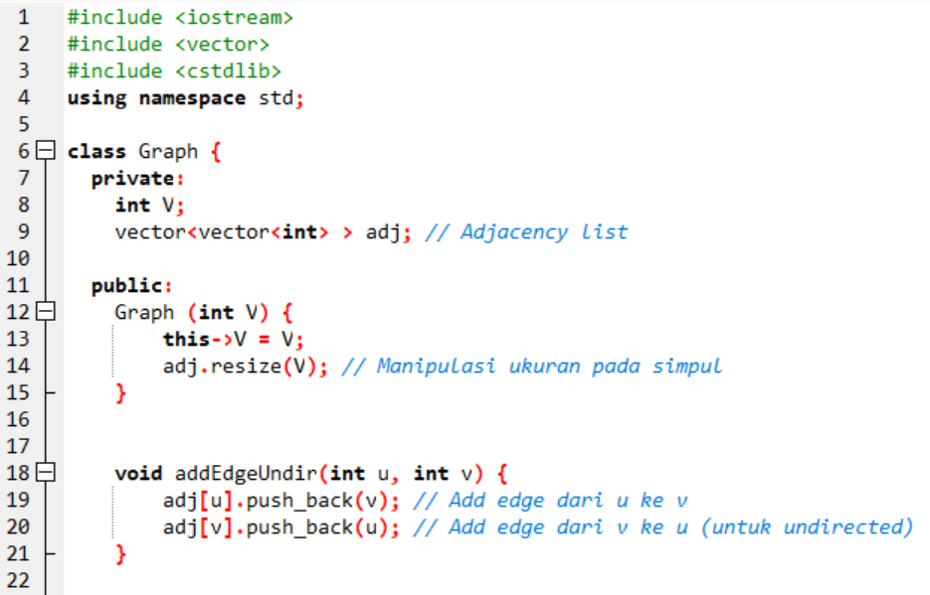

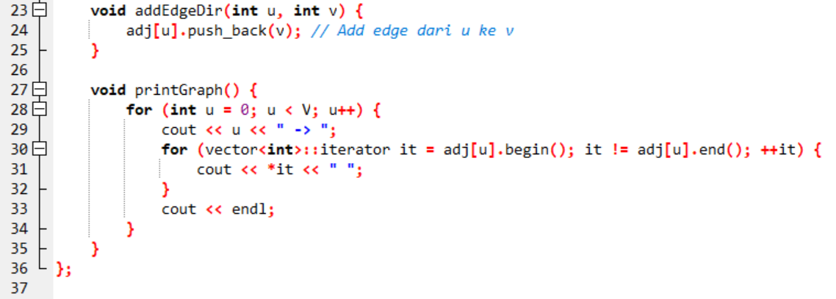

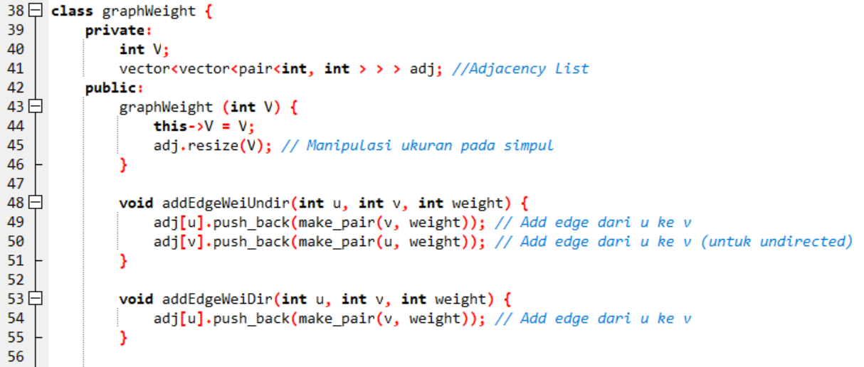

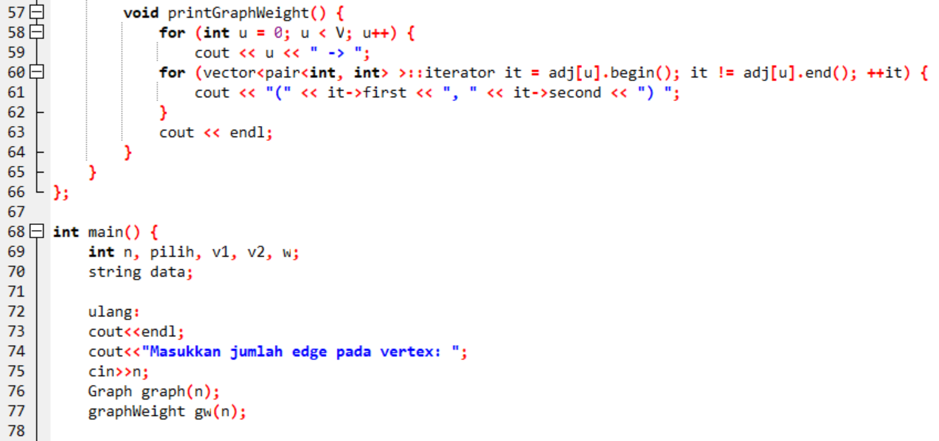

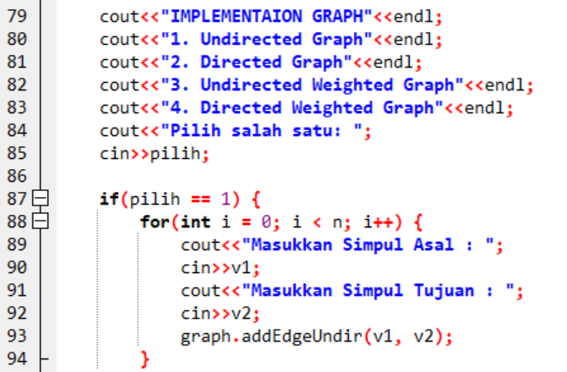

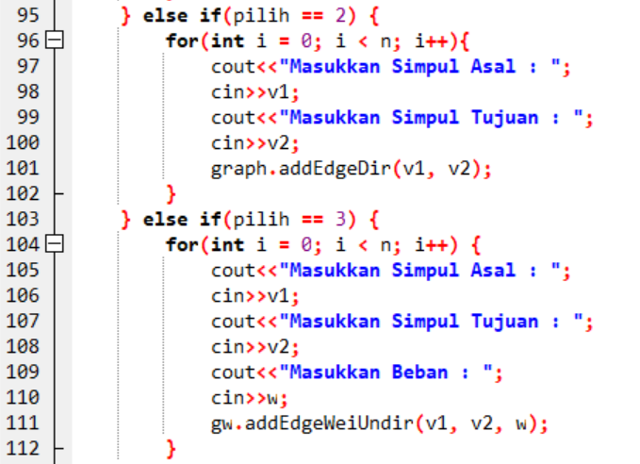

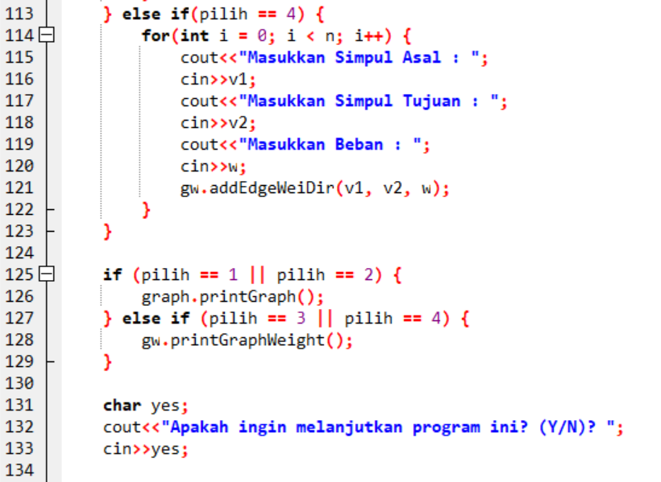

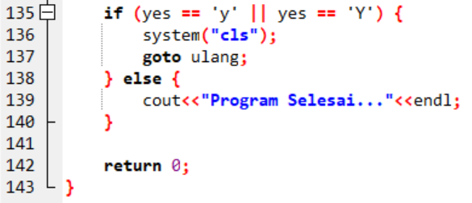

1. Screenshot Output
2. Undirected Graph

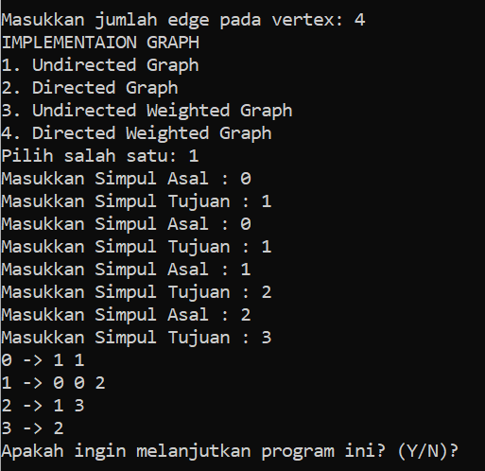

1. Directed Graph

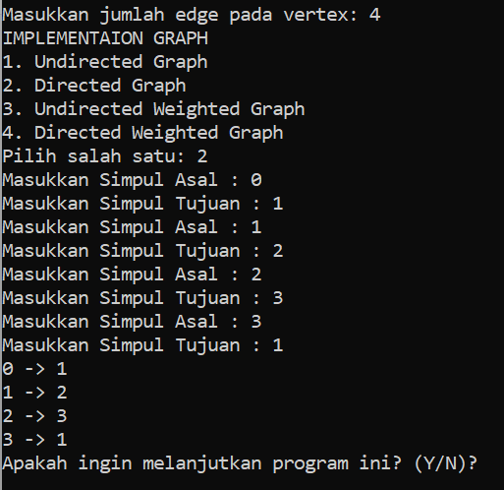

1. Undirected Weighted Graph

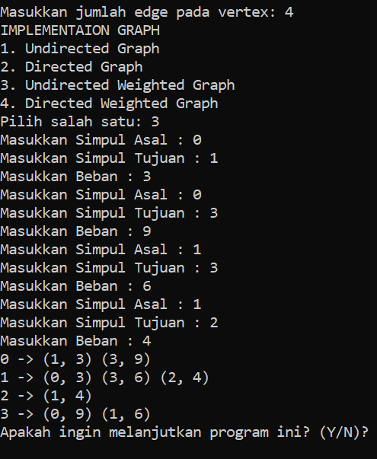

1. Directed Weighted Graph

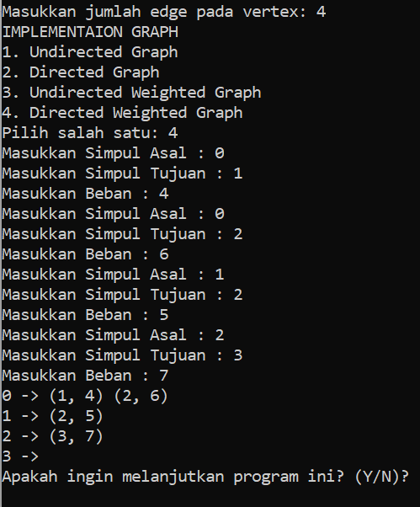

1. Screenshot jam pengerjaan

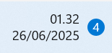

1. **Buatlah program C++ yang menghasilkan output seperti di modul hal. 77**
2. Screenshot Source Code

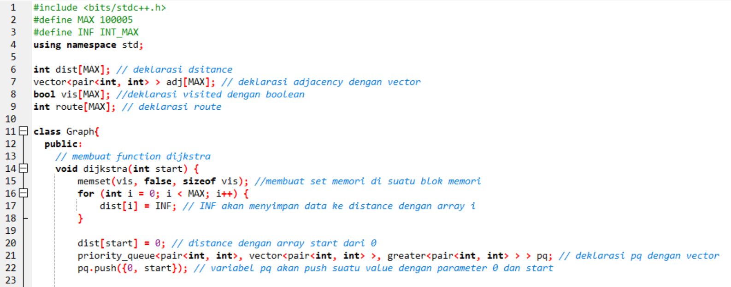

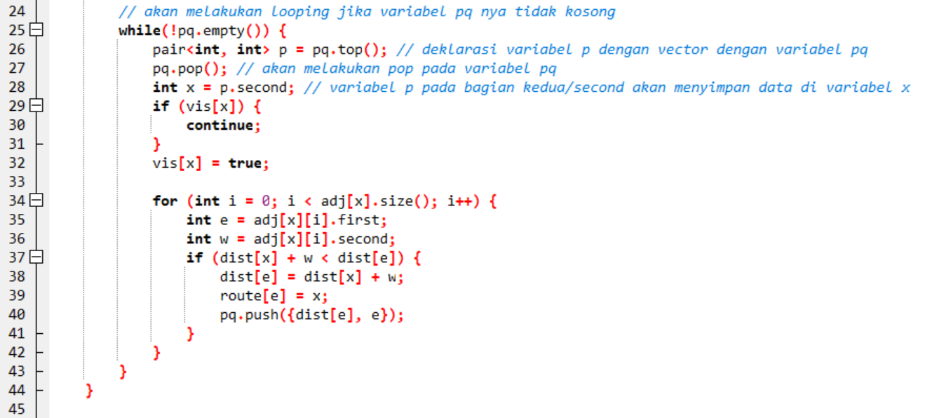

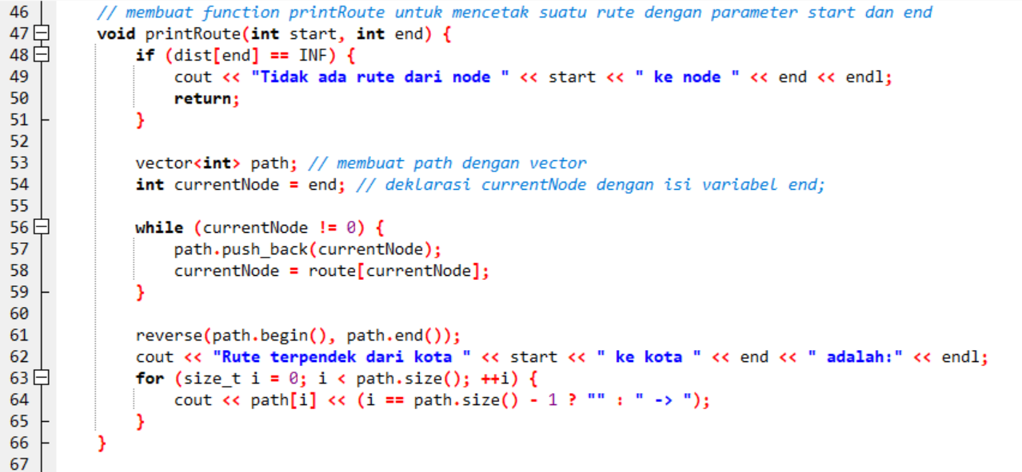

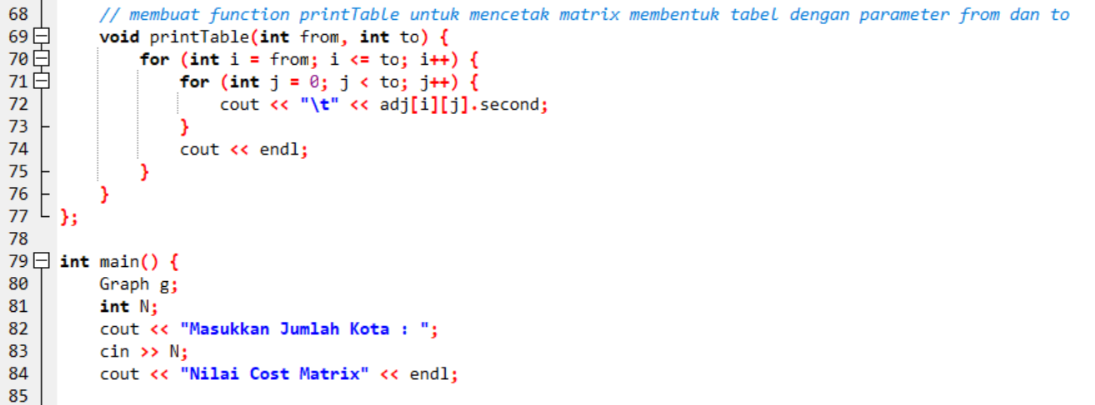

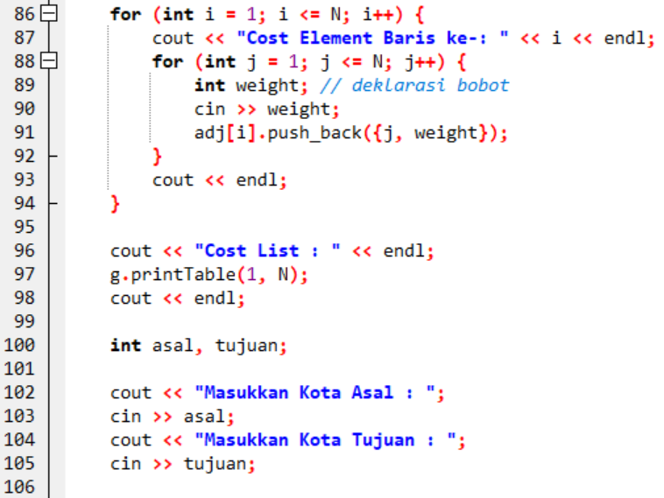

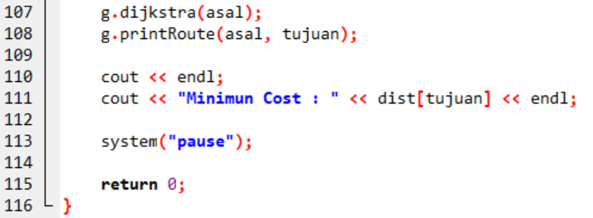

1. Screenshot Output

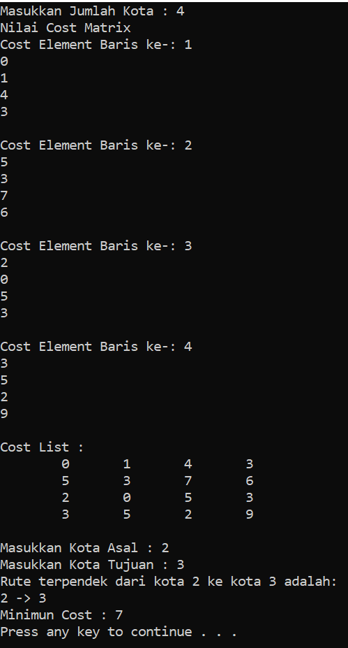

1. Screenshot jam pengerjaan

